**Browsing:**

Browsing is one of the most important feature of a website, especially for a car selling website. It has great impact on user experience for the website, a good browsing feature can give user easy access to the target items, however, a bad browsing feature will prevent user from accessing the target items and sometimes even browse the wrong items.

How it works:

According to the input, using SQL to select proper table or a specific record. Users are able to browse the items by traversing the category tree. At each point, they are given a summary of all the items that appear in that category.

Design:

A good browning feature should have the following attributes:

1. Easy to use (good design)
2. Accurate (well built database and proper SQL instructions)
3. Quick response (well built database and proper SQL instructions)

Browsing is usually done by a browsing bar. There are two types of browsing bar in our website: horizontal bar and vertical bar.

Horizontal bar is on the top of the page and vertical bar (box) is on the right of the page.

horizontal bar consists of 2 buttons and 3 drop-down menus:

On the main page, browsing bar is placed horizontally on top of the page which is a striking position. By doing this, it provides easy access for users to browse our inventory right after they enter the website. 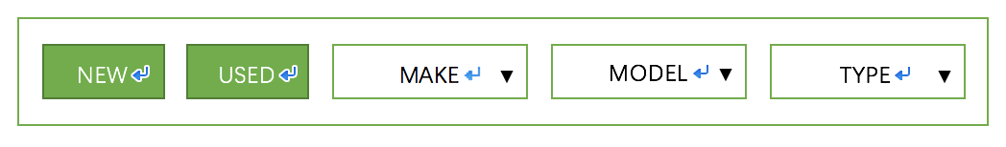

New Car button and Used Car button: User can select New car, used car, or both to browse our inventory. User can combine buttons with drop-down menus to filter out undesired results. Results will be displayed after button selection.

~~SELL YOURS button: Take user to sell page.~~

Drop-down menus: For users who have a target car in mind. First, select make of the car and then select model will take them to the result selected from our database according to the given input. Or users can browse the car by type (sedan, coupe, SUV, other), and jump to the result page with cars of that type.

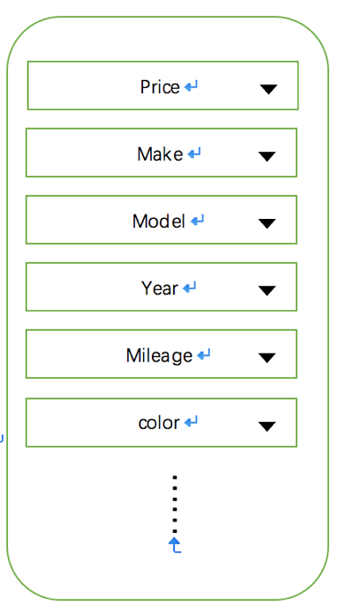All inventory pages have a vertical browse bar with all the attributes according to previous input (new/used/type…)

The reason that it is on vertical and on the right is that user are not disturbed by drop-down menus and focus more one the content.

Every change of the drop-down menu will immediately execute a SQL instruction and bring the result to the page.